**How to get started with GRUB2.**

**Presentation of GRUB2**

**GRUB2** is the new Linux bootloader. **GRUB2** stands for **GR**and **U**nified **B**ootloader version **2**.

As **GRUB** was not maintained for some time and lacked some critical features like **GPT** management needed to handle disks bigger than 2.4TB, it was decided to start a new version from scratch with modularity in mind.

**GRUB2** provides the following new features:

* ability to boot on various file systems (xfs, ext4, ntfs, hfs+, raid, etc),
* gzip files decompression on the fly,
* management of all disk geometries,
* support for **GPT** (**G**UID **P**artition **T**ables) and **MBR** (**M**aster **B**oot **R**ecord),
* portability with different architectures (BIOS, EFI, Coreboot, etc),
* ability to load modules at execution time.

[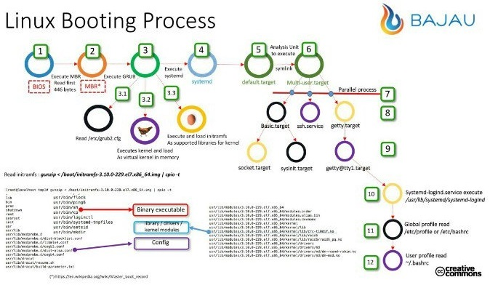](https://www.certdepot.net/wp-content/uploads/2015/11/LinuxBootingProcess.jpg)

**GRUB2 Organization**

The **GRUB2** configuration is spread over several files:

* **/boot/grub2/grub.cfg**: this file contains the final **GRUB2** configuration (do not edit it directly!),
* **/etc/grub2.cfg**: this is a symbolic link to the **/boot/grub2/grub.cfg** file,
* **/etc/default/grub**: this file contains the list of the **GRUB2** variables (the values of the environment variables can be edited),
* **/etc/sysconfig/grub**: this is a symbolic link to the **/etc/default/grub** file,
* **/etc/grub.d**: this directory contains all the individual files internally used by **GRUB2**.

This tutorial will only explore knowledge required for the **RHCSA** exam.  
Refer to the **Additional Resources** section for more details.

**Basic Management**

To get the details about the current active kernel, type:

# **grub2-editenv list**

saved_entry=CentOS Linux (3.10.0-229.11.1.el7.x86_64) 7 (Core)

Note: This information is stored in the **/boot/grub2/grubenv** file.

To get the list of the kernels displayed at boot time, type:

# **grep ^menuentry /boot/grub2/grub.cfg**

menuentry 'CentOS Linux (3.10.0-229.20.1.el7.x86_64) 7 (Core)' ...

menuentry 'CentOS Linux (3.10.0-229.14.1.el7.x86_64) 7 (Core)' ...

menuentry 'CentOS Linux 7 (Core), with Linux 0-rescue-f19b719117b44bf3a3fb777bd4127' ...caf

To permanently define the kernel to execute at boot time (here **0** for the first entry), type:

# **grub2-set-default 0**

To display the **GRUB2** variables, type:

# **cat /etc/default/grub**

GRUB_TIMEOUT=5

GRUB_DISTRIBUTOR="$(sed 's, release .*$,,g' /etc/system-release)"

GRUB_DEFAULT=saved

GRUB_DISABLE_SUBMENU=true

GRUB_TERMINAL="serial console"

GRUB_SERIAL_COMMAND="serial --speed=115200"

GRUB_CMDLINE_LINUX="rd.lvm.lv=rhel/swap crashkernel=auto rd.lvm.lv=rhel/root console=ttyS0,115200"

GRUB_DISABLE_RECOVERY="true"

Where

* **GRUB_TIMEOUT** defines the boot waiting delay (here **5** seconds),
* **GRUB_DISTRIBUTOR** contains the distribution name (here **CentOS Linux**),
* **GRUB_DEFAULT** specifies the default menu entry; it can be a number, an entry name or the string **saved** which means the entry saved during the last reboot or the execution of the **grub2-set-default** command,
* **GRUB_DISABLE_SUBMENU** allows (**false**) or not (**true**) the display of a submenu (see below),
* **GRUB_TERMINAL** defines the terminal input & output device (here **console** and **serial**),
* **GRUB_SERIAL_COMMAND** configures the serial port,
* **GRUB_CMDLINE_LINUX** specifies the command-line arguments added to the menu entries for the Linux kernel,
* **GRUB_DISABLE_RECOVERY** defines if all entries can be selected in recovery mode through a separate line (**false**) or only the default entry (**true**).

If you want to change the content of any variables in the previous file, you will need to type:

# **grub2-mkconfig -o /boot/grub2/grub.cfg**

Note: This is the main command to memorize for the exam. You can also replace **/boot/grub2/grub.cfg** with **/etc/grub2.cfg**

To better understand some of the environment variables, here are the standard display with **GRUB_DISABLE_RECOVERY**=”true” and **GRUB_DISABLE_SUBMENU**=true:

CentOS Linux 7 (Core), with Linux 3.10.0-229.20.1.el7.x86_64

CentOS Linux 7 (Core), with Linux 3.10.0-229.14.1.el7.x86_64

CentOS Linux 7 (Core), with Linux 0-rescue-f19b719117b44bf3a3fb777bd4127>

Use the ^ and v keys to change the selection.

Press 'e' to edit the selected item, or 'c' for a command prompt.

If **GRUB_DISABLE_RECOVERY** is set to “false”, here is the new display:

CentOS Linux 7 (Core), with Linux 3.10.0-229.20.1.el7.x86_64

CentOS Linux 7 (Core), with Linux 3.10.0-229.20.1.el7.x86_64 (recovery m>

CentOS Linux 7 (Core), with Linux 3.10.0-229.14.1.el7.x86_64

CentOS Linux 7 (Core), with Linux 3.10.0-229.14.1.el7.x86_64 (recovery m>

CentOS Linux 7 (Core), with Linux 0-rescue-f19b719117b44bf3a3fb777bd4127>

CentOS Linux 7 (Core), with Linux 0-rescue-f19b719117b44bf3a3fb777bd4127>

Use the ^ and v keys to change the selection.

Press 'e' to edit the selected item, or 'c' for a command prompt.

Each kernel line gets an associated line in recovery mode.

If **GRUB_DISABLE_RECOVERY** is now set to “true” (like in the initial standard display) and **GRUB_DISABLE_SUBMENU** is set tofalse, here is the new display:

CentOS Linux 7 (Core)

Advanced options for CentOS Linux 7 (Core)

Use the ^ and v keys to change the selection.

Press 'e' to edit the selected item, or 'c' for a command prompt.

If the first entry is selected (“CentOS Linux 7 (Core)”), the system boots. If the second option is chosen, the standard menu is shown with an additional line at the bottom to go back to the first menu with the Esc key:

CentOS Linux 7 (Core), with Linux 3.10.0-229.20.1.el7.x86_64

CentOS Linux 7 (Core), with Linux 3.10.0-229.14.1.el7.x86_64

CentOS Linux 7 (Core), with Linux 0-rescue-f19b719117b44bf3a3fb777bd4127>

Use the ^ and v keys to change the selection.

Press 'e' to edit the selected item, or 'c' for a command prompt.

Press Escape to return to the previous menu.